Perspectives on large landscape drought resilience in Idaho and Montana
Prepared by:
Lily Fanok, Dr. Chloe Wardropper & Dr. Morey Burnham
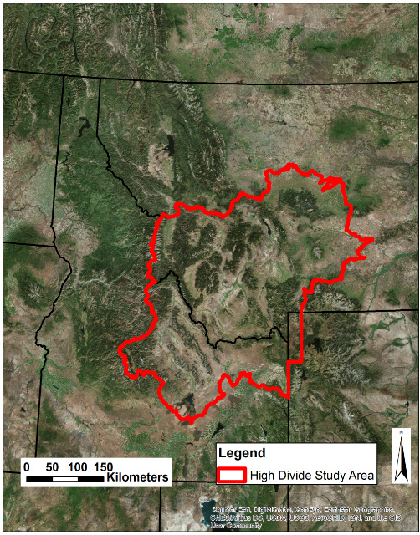
The High Divide region of Idaho and Montana covers approximately 25 million acres connecting the Greater Yellowstone Ecosystem and the Crown of the Continent. Increasing drought trends present challenges to land managers across the region; agricultural producers depend on adequate water supply for their livelihoods, while conservation organizations need water supply to sustain fish, wildlife, and plant species.

During the 2018 annual High Divide Collaborative meeting, we facilitated focus groups with attendees to understand how people living and working in the region perceive drought resilience. We asked stakeholders (including ranchers, non-profit representatives, government agency officials, and University researchers), the following questions:
(1) What experiences have you had with drought in the past?
(2) What do you perceive as the characteristics of a drought resilient landscape for wildlife connectivity, water availability, and ranch livelihoods?
(3) What needs to change to achieve a drought resilient landscape?
Within each small focus group, we recorded each participant’s responses by question, and then asked participants to vote on responses that were most like how they felt.

We summarized group discussions into three overarching themes, which we refer to as adaptive pathways, for increased drought resilience in the High Divide region:
- Building social connectedness describes the importance of collective social investment in the landscape and fostering human connection to the land.
- Supporting long-term functioning ecosystems describes the importance of hydrologic connectivity and supporting or incentivizing ecosystem services provision.
- Sustaining agricultural livelihoods describes the importance of enabling rancher participation in community decision making, building trust between social-economic sectors, and diversification of income for landowners including ranchers.

Table: Summary of top responses (by vote count) within sub-basin groups for responses to questions 2 and 3. Overarching themes are indicated with symbols.
 | Sub- Basin | What are the characteristics of a drought resilient landscape | What needs to change to achieve a drought resilient landscape?
Gallatin-Madison |  | - Enough water to keep working lands solvent  - Mutual respect between different people sharing the landscape  - Forest management activities leading to a drought resilient landscape | - Willingness to change personal behavior with respect to consumption pattern where we live/recreate  - Education awareness to affect attitudes  - Consistent support for monitoring
Ruby Centennial |  | - Community collaboration  - Proactive planning & capacity to adapt to change  - Adaptability & consistent sufficient stream flows to meet all beneficial uses | - Local community participation  - Culture change and attitude  - Capacity to plan and respond to changing conditions
Upper Snake |  | - Build socially administrative capacity for drought & Better job capturing and storing water on good years  - Flexible infrastructure  - Better connectivity/protection/conservation between most drought sensitive/tolerant habitats | - Build off Teton Valley model – identify places w/similar geography  - Maintain communication between stakeholders  - Additional infrastructure -- funding
Salmon-Lemhi |  | - Social agreement on drought plan & Accepting change  - Functioning ecosystems for increased resilience  - Functioning fire regimes | - Societal investment in landscape – monetary and social  - Marketing for environmental investment – value-based marketing  - Bridging rural and urban divide & Connection to land
Big Hole |  | - Ecologically intact systems – properly functioning  - Collaborative effort  - Flexibility on all levels | - Willingness to see multiple perspectives & promote working landscape of multiple uses  - Timber management  - Allocating funding for drought resilience
Overarching Themes:
Building Social Capital
Supporting Functioning Ecosystems
Sustaining Agricultural Livelihoods

We would like to thank the High Divide Collaborative for making this research possible.
Any feedback is welcome – please contact Lily Fanok at fano6757@vandals.uidaho.edu.

